**URS: CUSTOMER  
URS-01**: Customer can registration themselves as customer.

**Introduction:**

Customer register a customer’s information into the system.

**Input:** Customer request a registration Page.

|  |  |  |  |  |
| --- | --- | --- | --- | --- |
| **Name** | **Type** | **Description** | **Example** | **Remarks** |
| username | String | A username of customer | “camt1234” | 1-50 characters |
| password | String | A password of customer. | “camt1234” | 1-50 characters |
| name | String | A Full-Name of customer | “Putsacha” | 1-40 characters |
| birthDate | DATE | A birth date of customer. | “1993-02-25” | Format : yyyy/mm/dd |
| email | String | An email of customer. | “se542115000@vr.camt.info” | - |
| telephoneNumber | String | A telephone number of customer. | “0888888888” | 0-9 digits |
| address | String | An address of customer. | “CAMT” | 1-255 characters |
| picture | BLOB | A picture of customer. | C:\Users\wuthipong\Desktop\User\542115037.jpg | - |

**Flow of Execution:**

**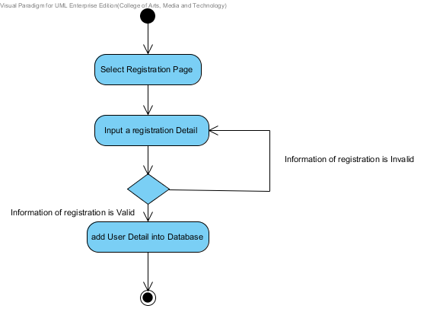**

**Output:**  The System add the registration of customer into database.

**System Requirement Specification**  
 **SRS-01:** The system provide an interface for registration which receive username, password,   
 name address and their picture for the registration.   
 **SRS-02:** The system can check the name format. The name format should be only a   
 character.  
 **SRS-03:** The system can check the address. The address format should be a characters   
 between 1-255 characters.  
 **SRS-04:** The system can check the picture that user uploading. The picture should be an   
 image format such as, .png, .jpg.  
 **SRS-05:** The system can check the username format. The username format should be   
 characters.  
 **SRS-06:** The system can check the password format. The password format should be   
 characters.  
 **SRS-07**: The system shall connect to the database.  
 **SRS-08**: The system retrieve information from the database.  
 **SRS-09:** The system shall add a new customer information to database using username,   
 password, name, address and their picture.  
 **SRS-10:** The system shall provide the successful registration page after registration is   
 complete.  
 **SRS-11:** The system shall display the error message “The username must be characters”.  
 **SRS-12:** The system shall display the error message “The password must be characters”.  
  **SRS-13:** The system shall display the error message “The name must be only characters”.  
 **SRS-14:** The system shall display the error message “The address must be a characters   
 between 1-255 characters”.  
 **SRS-15:** The system shall display the error message “The picture must be image format”.

**URS-02**: Customer can login to the system.

**Introduction:**

Customer login into the system.

**Input:** Customer request a Login Page.

|  |  |  |  |  |
| --- | --- | --- | --- | --- |
| **Name** | **Type** | **Description** | **Example** | **Remarks** |
| username | String | A username of customer. | “camt1234” | 1-50 characters |
| password | String | A password of customer. | “camt1234” | 1-50 characters |

**Flow of Execution:**

**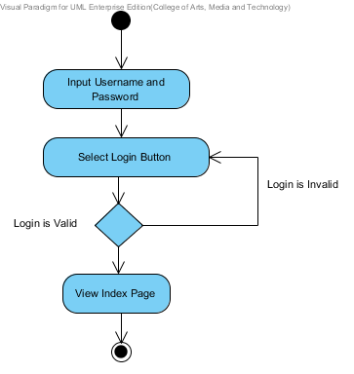**

**Output:**  Customer login to the system.

**System Requirement Specification**  
 **SRS-16:** The system provides the login interface which receive the user name and password.  
 **SRS-17:** The system can check the username format. The username format should be   
 characters.  
 **SRS-18:** The system can check the password format. The password must contain the   
 characters.  
 **SRS-19:** The system validates the username and password.  
 **SRS-20:** The system shall provide the successful login page.  
 **SRS-07**: The system shall connect to the database.  
 **SRS-08**: The system retrieve information from the database.  
 **SRS-21:** The system shall show the user status with a customer picture on the top-right of   
 the user interface to confirm his identity.

**URS-03**:Customer can view all the product category.

**Introduction:**

Customer view all the product category in Product Page.

**Input:** Customer request a Product Page.

**Flow of Execution:**

**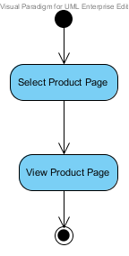**

**Output:**  The system show all the product detail in Product Page.

**System Requirement Specification**  
 **SRS-22:** The system provide an interface that show all the product category including, name,   
 description, price and image.   
 **SRS-07**: The system shall connect to the database.  
 **SRS-08**: The system retrieve information from the database.  
 **SRS-23:** The system show the product detail that consist of name, description, price and   
 image.

**URS-04:** Customer can search the product.

**Introduction:**

Customer can search a product detail by using product’s name.

**Input:** Customer request a Product Page.

|  |  |  |  |  |
| --- | --- | --- | --- | --- |
| **Name** | **Type** | **Description** | **Example** | **Remarks** |
| name | String | A product’s name. | “C” | 1-50 characters |

**Flow of Execution:**

**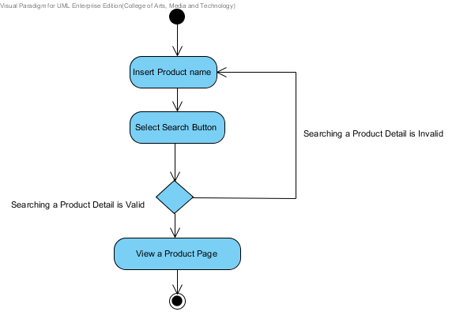**

**Output:**  The system show a product in Product Page.

**System Requirement Specification**  
 **SRS-24:** The system shall provide interface to search a product page which receive product   
 name for searching.  
 **SRS-07**: The system shall connect to the database.  
 **SRS-25**: The system retrieve information from the database by name.  
 **SRS-26:** The system shall provide detail page that consist with product name, product   
 description, and product picture.

**URS-05**: Customer can add the product as many products as customer want to the   
 shopping cart.

**Introduction:**  Customer can add a product into shopping Cart by click “Add Cart” button on Product page.

**Input:** Click “Add Cart” Button.

|  |  |  |  |  |
| --- | --- | --- | --- | --- |
| **Name** | **Type** | **Description** | **Example** | **Remarks** |
| Add Cart | Button | User Interface | Add Cart | 1 time |

**Flow of Execution:**

**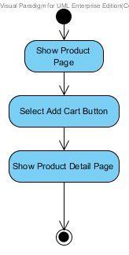**

**Output:**  The system show updating products on Shopping Cart Page.

**System Requirement Specification**   
 **SRS-27:** The system shall provide the interface to add new product which user selected.  
 **SRS-28:** The system add the product that user is selected into the shopping cart.

**SRS-07**: The system shall connect to the database.  
 **SRS-29:** The system shall update the product that user is selected into the database.  
 **SRS-30:** The system shall provide the successful add new product page after user add new   
 product into the shopping cart.

**URS-06:** Customer can edit the product in the shopping cart.

**Introduction:**  Customer can delete or update product in Shopping Cart list.

**Input:** Customer select remove check box and input number of each product.

|  |  |  |  |  |
| --- | --- | --- | --- | --- |
| **Name** | **Type** | **Description** | **Example** | **Remarks** |
| Check box | True/False | The check box UI for remove item. |  | Checked box is remove and Empty box is keep the item |
| amount | number | The number increase one step per |  | - |

**Flow of Execution:**

**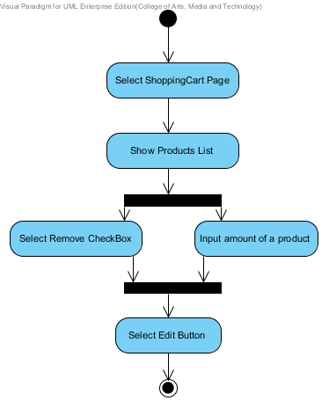**

**Output:**  The system update Shopping Cart Page.

**System Requirement Specification**  
 **SRS-07**: The system shall connect to the database.  
 **SRS-31**: The system shall delete the products from the database.  
 **SRS-32:** The system shall update amount of the products into database.  
 **SRS-33**: The system shall display the error message “The system cannot edit the new   
 updating”.  
 **SRS-34**: The system shall display the message “Edit Completed” when updated in the   
 database.  
 **SRS-35**: The system provide an interface for edit function.

**URS-07:** Customer can save the product in the shopping cart.

**Introduction:**  Customer save products into Shopping Cart system.

**Input:** Customer select “save” button.

**Flow of Execution:**

**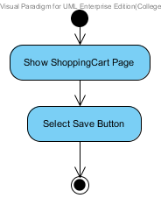**

**Output:**  Update product to Shopping Cart.

**System Requirement Specification**  
 **SRS-07**: The system shall connect to the database.  
 **SRS-36:** The system shall update information into the database.  
  **SRS-37:** The system shall display error message “The system cannot save the new product”.  
 **SRS-38:** The system shall display error message “The system cannot connect to the   
 database”.  
 **SRS-39:** The system shall display the message “Save Completed” when updated in the   
 database.  
 **SRS-40:** The system provide an interface for save function.

**URS-08:** Customer can check out for purchase the product.

**Introduction:**

**Input:** Customer request a Check Out Page.

**Flow of Execution:**

**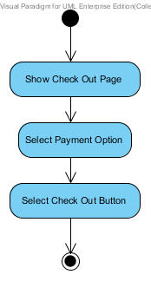**

**Output:**  The system show status of purchase.

**System Requirement Specification**  
 **SRS-07**: The system shall connect to the database.  
 **SRS-08**: The system retrieve information from the database.  
 **SRS-36**: The system update product information in database.  
 **SRS-41**: The system shall provide an interface for Check out function.  
 **SRS-22:** The system provide an interface that show all the product category including, name,   
 description, price and image  
 **SRS-42:** The system shall provide an interface for select the payment option including,   
 Transfer, Credit card and PayPal.  
 **SRS-43:** The system shall update payment option into the database.  
 **SRS-44:** The system shall display message “Purchase successful” when the transect amount   
 from banking system.

**URS-09:** Customer can view the shopping history.  
 **SRS-45:** The system provide an interface for the shopping history page.  
 **SRS-46**: The system retrieve shopping history form the database by reference from user.  
**URS-10:** Customer can logout.

**Introduction:**

Customer logout off the system.

**Input:** Customer select a Logout Button.

**Flow of Execution:**

**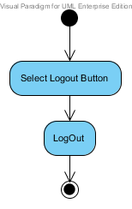**

**Output:**  Customer logout off the system.

**System Requirement Specification**  
 **SRS-47:** the system provide an interface for logout.  
 **SRS-48:** The system doesn’t show a user status on top right after logout successful.

**URS: ADMINISTRATOR  
URS-11**: Administrator can login to the system.

**Introduction:**  Administrator login into the system.

**Input:** Administrator request a Login Page.

|  |  |  |  |  |
| --- | --- | --- | --- | --- |
| **Name** | **Type** | **Description** | **Example** | **Remarks** |
| username | String | A username of customer. | “camt1234” | 1-50 characters |
| password | String | A password of customer. | “camt1234” | 1-50 characters |

**Flow of Execution:**

****

**Output:**  Administrator login to the system.

**System Requirement Specification**  
  
 **SRS-16:** The system provides the login interface which receive the user name and password.  
 **SRS-17:** The system can check the username format. The username format should be   
 characters.  
 **SRS-18:** The system can check the password format. The password must contain the   
 characters.  
 **SRS-19:** The system validates the username and password.  
 **SRS-20:** The system shall provide the successful login page.  
 **SRS-07**: The system shall connect to the database.  
 **SRS-08**: The system retrieve information from the database.  
 **SRS-21:** The system shall show the user status with a customer picture on the top-right of   
 the user interface to confirm his identity

**URS-12:** Administrator can view the shopping history of all customer.  
 **SRS-44:** The system provide an interface for the shopping history page.  
 **SRS-45**: The system retrieve shopping history form the database by reference from user.  
 **SRS-49**: The system retrieve shopping history form the database by reference from date.  
 **SRS-50:** The system provide an interface that show all the shopping history of all customer.

**URS-13:** Administrator can provide detail of the product.

**Introduction:**

Administrator add a product’s information into the system.

**Input:** Administrator request a Product Page.

|  |  |  |  |  |
| --- | --- | --- | --- | --- |
| **Name** | **Type** | **Description** | **Example** | **Remarks** |
| name | String | A name of product. | “channel” | 1-50 characters |
| description | String | A description of product. | “Handle Bag” | 1-255 characters |
| price | Double | A price of product. | “110.25” | - |
| Image | BLOB | An image of product. | C:\Users\wuthipong\Desktop\Project Component Based\อิอิอิ\woman\fendi\4\394387_bk_xl.jpg | - |

**Flow of Execution:**

**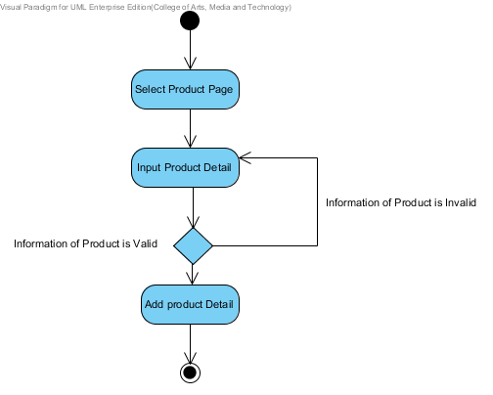**

**Output:**  The System add the product into database.

**System Requirement Specification**  
 **SRS-51:** The system provide an interface for update a product which receive name,   
 description, price and image.  
 **SRS-07**: The system shall connect to the database.  
 **SRS-36**: The system update information into database.

**URS-14:** Administrator can update all information of registration.

**Introduction:**

Administrator can update a registration of customer into the system.

**Input:** Administrator request a registration Page.

|  |  |  |  |  |
| --- | --- | --- | --- | --- |
| **Name** | **Type** | **Description** | **Example** | **Remarks** |
| username | String | A username of customer | “camt1234” | 1-50 characters |
| password | String | A password of customer. | “camt1234” | 1-50 characters |
| name | String | A Full-Name of customer | “Putsacha” | 1-40 characters |
| birthDate | DATE | A birth date of customer. | “1993-02-25” | Format : yyyy/mm/dd |
| email | String | An email of customer. | “se542115000@vr.camt.info” | - |
| telephoneNumber | String | A telephone number of customer. | “0888888888” | 0-9 digits |
| address | String | An address of customer. | “CAMT” | 1-255 characters |
| picture | BLOB | A picture of customer. | C:\Users\wuthipong\Desktop\User\542115037.jpg | - |

**Flow of Execution:**

**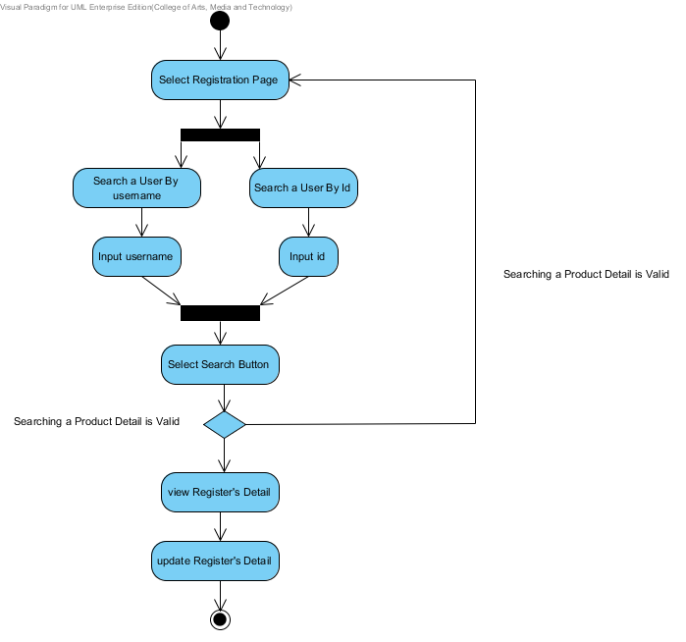**

**Output:**  The System update the registration of customer into database.

**System Requirement Specification**  
 **SRS-52:** The system provide an interface for update the registration which receive   
 username, password, name, address and their picture for the registration.  
 **SRS-07**: The system shall connect to the database.  
 **SRS-36:** The system shall update all information into database.

**URS-15:** Administrator can logout.

**Introduction:**

Administrator logout off the system.

**Input:** Administrator select a Logout Button.

**Flow of Execution:**

****

**Output:**  Administrator logout off the system.

**System Requirement Specification**  
 **SRS-47:** the system provide an interface for logout.  
 **SRS-48:** The system doesn’t show a user status on top right after logout successful.